Low Country AGO *eNewsletter* – September, 2024

Dear Colleagues and Friends,

Thank you to all that attended last week's AGO cookout hosted by Debby Graves. The joy, fun, conversation, and laughter was invigorating.......not to mention the food!  Fellowship and networking is such a major part of organizations like this.  It was great to see new faces and rekindle relationships with those from years past.    How amazing it is for each of us to be connected in some way due to organ music or the appreciation of organ music!

I'd like to especially thank Debby for her hard work in coordinating, preparing, hosting, and cooking at the event!  She did an outstanding job!

 As we move forward in the fall of the year, please plan to participate in/attend/promote as many programs you can because without YOU, there is no chapter.  It's because of you and your support that we can offer programs like the silent movie in October, the organ concerts/recitals spread around Beaufort County, and the joint-choir Festival of Hymns in May of 2025.  It is going to be a spectacular year filled with amazing music and great fellowship. Kudos to the members of our chapter for making that possible!

In closing, remember what Lawrence Welk said:  Keep a song in your heart!

Chad A. Martin

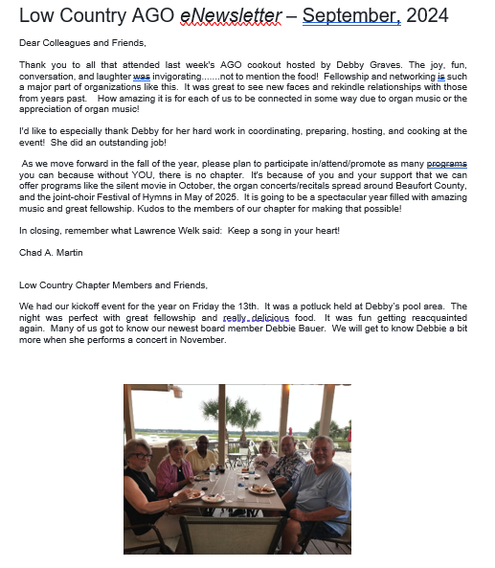

Low Country Chapter Members and Friends,

We had our kickoff event for the year on Friday the 13th.  It was a potluck held at Debby’s pool area.  The night was perfect with great fellowship and really delicious food.  It was fun getting reacquainted again.  Many of us got to know our newest board member Debbie Bauer.  We will get to know Debbie a bit more when she performs a concert in November.

Our next event will be held on October 29th at First Presbyterian Church on Hilton Head Island.  Chad will be accompanying a Silent Movie, NOSFERATU, (A Symphony of Horror) at 6:30 PM.  NOSFERATU is a 1922 silent German Expressionist Vampire Film.  This will be the perfect Halloween Movie.

Debbie Bauer will be presenting a NOON organ concert at Carteret United Methodist Church in Beaufort on Friday November 22nd.  Debbie recently moved to Beaufort from Columbia, SC.

Our December event will be at Glenn and Cathy Ragsdale’s on Spring Island.  The date is December 6th at 5:30 PM.  This will be a potluck so let’s have some really delicious holiday food.  More details to come.

I hope to see you all very soon,

Debby

